Assignment Module 2: Installation and Maintenance of Hardware and Its Components

🔹 Section 1: Multiple Choice Questions
Q1. Which of the following precautions should be taken before working on computer hardware?
Answer: Wear an anti-static wrist strap to prevent damage from electrostatic discharge.

Q2. What is the purpose of thermal paste during CPU installation?
Answer: To improve the thermal conductivity between the CPU and heat sink.

Q3. Which tool is used to measure the output voltage of a power supply unit (PSU)?
Answer: Multimeter.

Q4. Which component stores BIOS settings (date, time) even when power is off?
Answer: CMOS Battery.

🔹 Section 2: True or False
Q5. When installing a new hard drive, it is essential to format it before use.
Answer: True.

Q6. A POST (Power-On Self-Test) error indicates a problem with the CPU.
Answer: False.

Q7. It is safe to remove a USB flash drive without ejecting it first.
Answer: False.

🔹 Section 3: Descriptive Questions

Q8. Steps to Install a Graphics Card
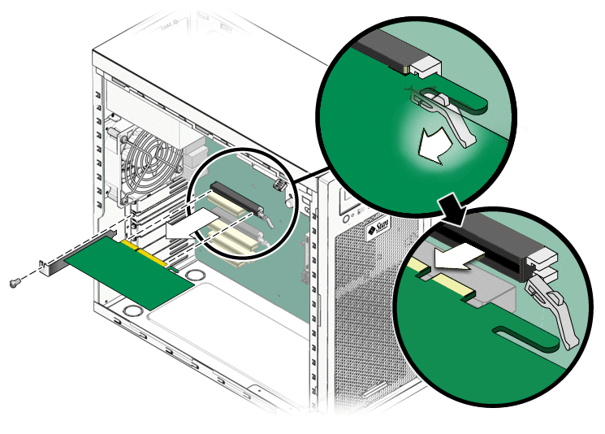
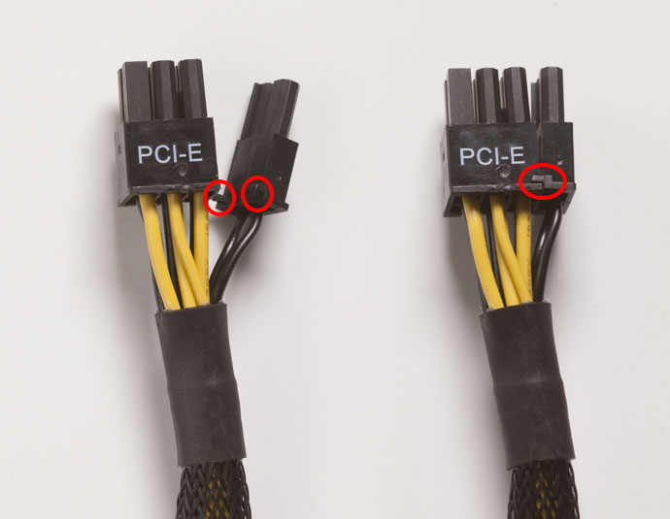
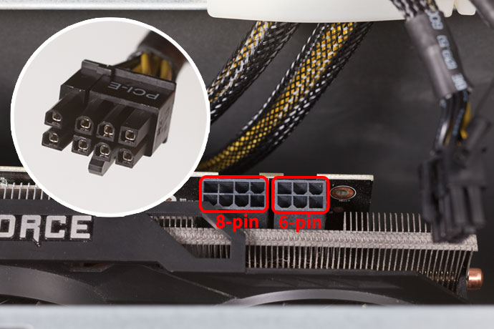
Answer:
- Power down and unplug the computer
- Ground yourself to avoid static damage
- Open the computer case
- Locate the PCIe x16 slot
- Remove expansion slot covers
- Insert the graphics card firmly
- Connect power cables (if required)
- Close the case
- Plug in and boot the system
- Install necessary drivers

Q9. What is RAID? Explain common RAID configurations
Answer:
RAID (Redundant Array of Independent Disks) is a technology that combines multiple storage drives into a single system to improve performance, reliability, or both.
Common RAID Types:
- RAID 0 (Striping):
High speed, no data protection
- RAID 1 (Mirroring):
Data is duplicated, high safety
- RAID 5 (Striping with Parity):
Balanced performance and fault tolerance
- RAID 6 (Dual Parity):
Can survive two drive failures
- RAID 10 (1+0):
Combines speed and redundancy

Q10. Steps to Replace a CPU Fan
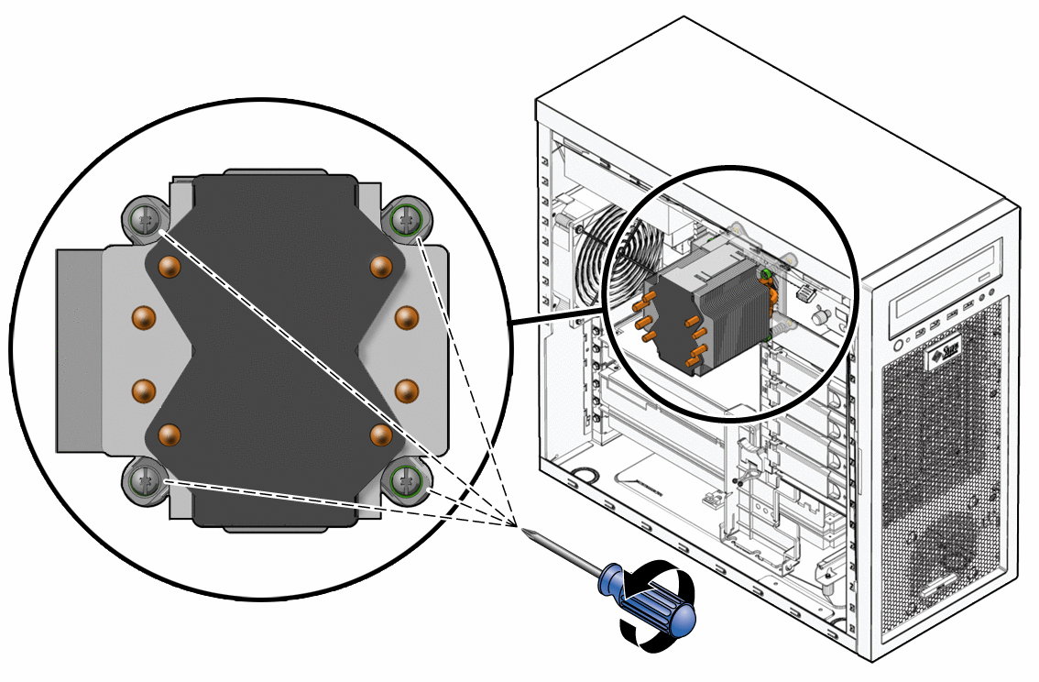
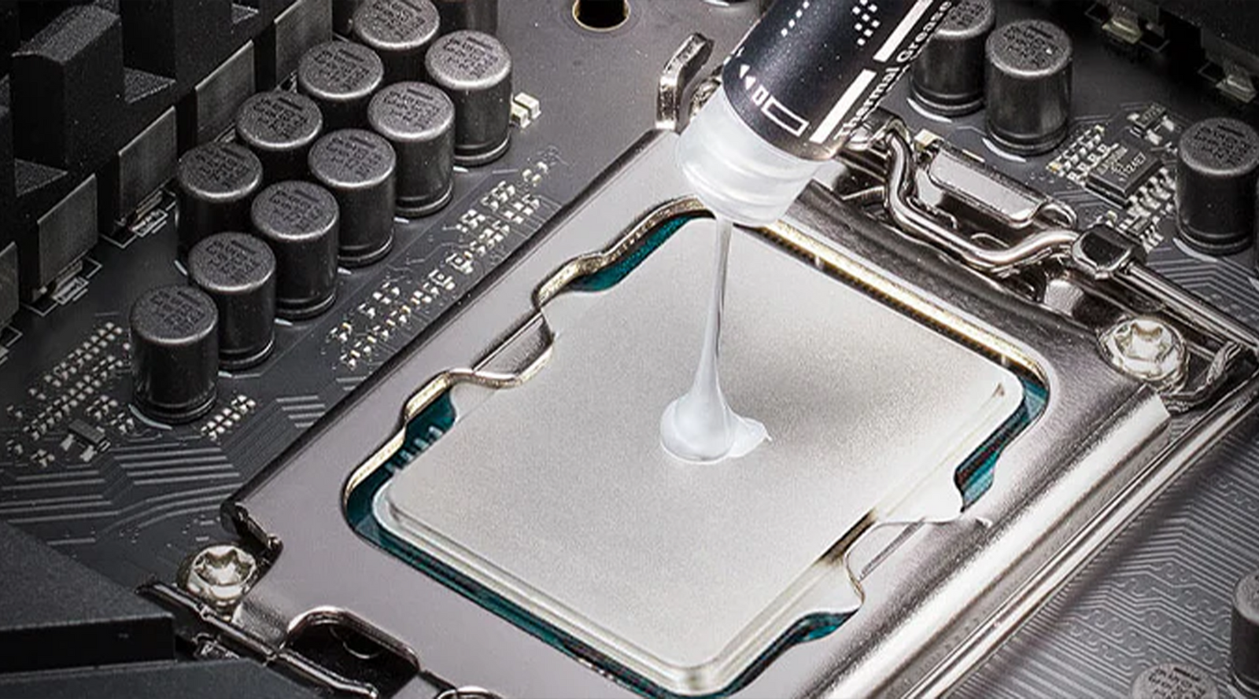
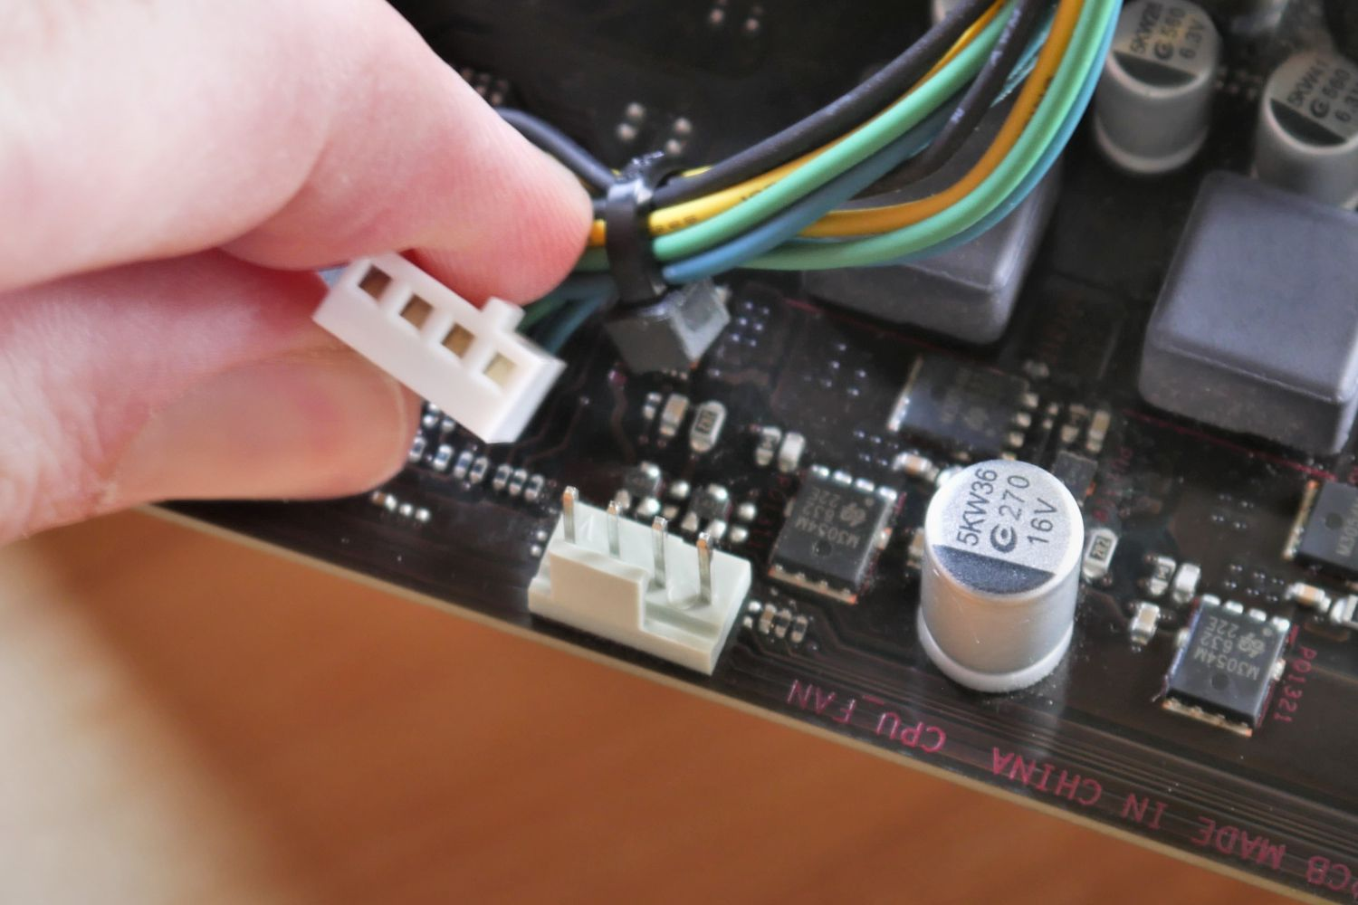
4
Answer:
- Power off and unplug the computer
- Ground yourself
- Open the case
- Locate the CPU fan
- Disconnect fan cable
- Remove old fan and heatsink
- Clean old thermal paste
- Apply new thermal paste
- Install new CPU fan
- Reconnect cable
- Close case and power on system

Q11. Importance of Regular Hardware Maintenance
Answer:
Importance:
- Increases hardware lifespan
- Improves system performance
- Prevents unexpected failures
- Protects important data
Maintenance Tasks:
- Cleaning dust from components
- Replacing thermal paste
- Checking cooling fans
- Managing cables properly
- Monitoring hard drive health
- Checking loose connections
- Updating BIOS and firmware

